
CURRICULUM

VITAE

Of

Asmaa Abd Al Aziz Ebrahim Soliman

Faculty

of

Medicine
Benha Unive

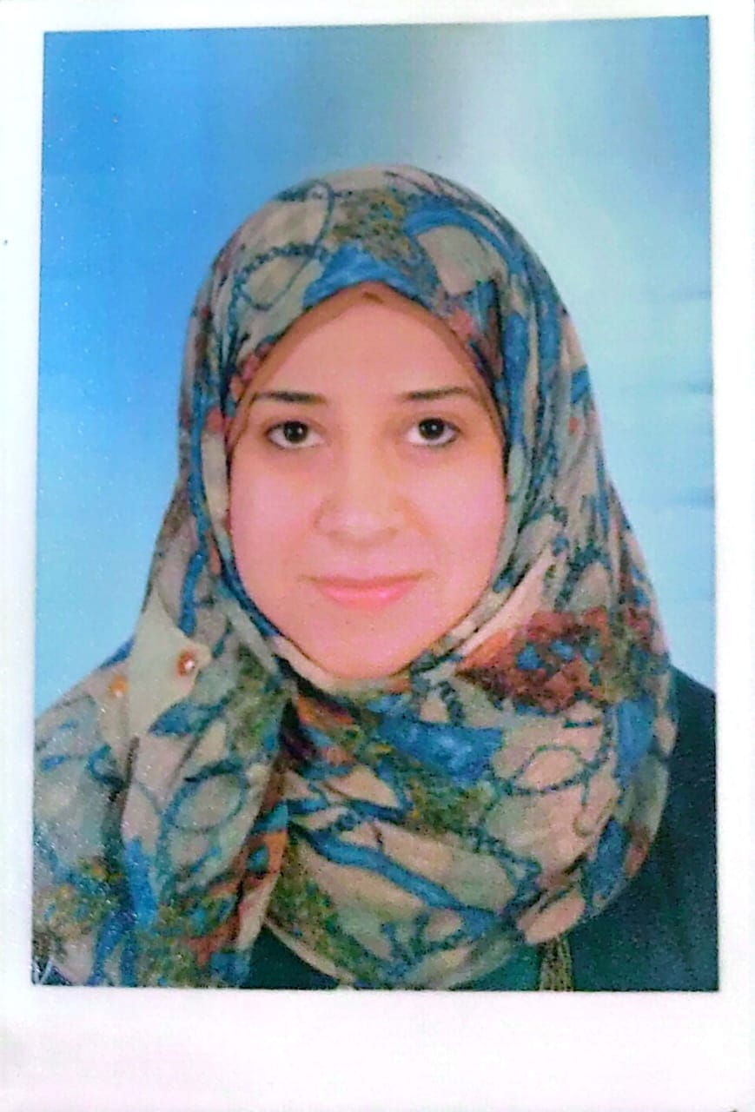

Personal photo

1. Personal Data: -

Name (Arabic) | أسماء عبد العزيز ابراهيم سليمان
Name (English) | Asmaa Abd Al Aziz Ebrahim Soliman
Department | Forensic Medicine and Clinical Toxicology
College | Faculty of Medicine
Academic degree | Lecturer
Mobile | 01224208603
Home phone | 0133271686
work phone
Email (university) | asmaa.ibrahim@fmed.bu.edu.eg
Alternative E mail | asmaaabdelaziz180@yahoo.com

2. Education: -

Institution | Degrees obtained | Year
Benha University | Bachelor of Medicine and Surgery, Faculty of Medicine.  DEGREE: Excellent with honor degree. | December 2011
Benha University | Master’s Degree of Forensic Medicine and clinical toxicology, Faculty of Medicine.  DEGREE: Very good. | April 2019
Benha University | Doctorate Degree of Forensic Medicine and clinical toxicology, Faculty of Medicine.  DEGREE: Very good. | April 2024

General specialty | Forensic and Toxicology
Specific specialty | Forensic medicine and Clinical Toxicology

Language

Language | Reading | Speaking | Writing
Arabic | Fluent | Fluent | Fluent
English | Fluent | Fluent | Fluent

3. Membership of Professional Bodies (List): -

•
•

4. Interesting Areas of Research: -

- Forensic Medicine
- Clinical Toxicology

4.1. MSc Supervision

Title | Year completed / in  Progress

4.2. PhD Supervision

Title | Year completed / in progress

5. Positions: -

Date From  - to |  | Organization | Country | Position | Role
1 | July 2013 to April  2019 | Benha faculty of medicine | Egypt | Demonstrator
2 | May 2019 to April  2024 | Benha faculty of medicine | Egypt | Assistant lecturer
3 | May 2024 till now | Benha faculty of medicine | Egypt | Lecturer

6. Attended Workshops, Symposiums, and Conference: -

Name of Workshops, Symposiums, and Conferences | Year
- (Our home is a trust) initiative, 2019.
- “Together for a clean sport” initiative against Steroids, December 2019.
- “Hope” initiative against COVID-19 virus, May 2020.
- Attending & participating as organizer and introducer of the 1st Conference of forensic Medicine & clinical Toxicology Department of Benha Faculty of Medicine held on December 2018.
- Attending 1st Benha Faculty of Medicine quality conference, October 2018.
- Attending & participating as conference coordinator of the 2nd Conference of forensic Medicine & clinical Toxicology Department of Benha Faculty of Medicine held on November 2020.

7.Training and Clinical Experience: -

- Experience with clinical toxicology management.
- Experience with Forensic cases diagnosis and reports.
- Teaching activities “Forensic Medicine and Clinical Toxicology “for 4th grade students, Benha Faculty of Medicine.
- Editor of the postgraduates' Directory, Forensic Medicine & Clinical Toxicology Department, Benha University, 2019.
- Member of general administration of examination, first part of master degree.

8. Skills: -

- Lecturer for undergraduate students at Faculty of Medicine both Forensic medicine and Toxicology subjects.
- I am a lecturer for postgraduate students at Faculty of Medicine both Forensic medicine and Toxicology subjects.
- Supervise Student’s academic activities.
- Member of the Editorial board of Biannual forensic Sciences and Toxicology Journal.
- Participated in the administrative duties of the clinical project of the Poison and Drug Analysis Laboratory.
- Participated in developing the curriculum of the Crime Scene Investigation Diploma and also took part of teaching the post graduate students.
- Trainer in newly graduated workshops.
- Developed a fully programmed Toxicological cases webinar in 2021.
- Experienced in dealing with emergent acute poisoned patients.
- Put management plan for poisoned patients.
- Take responsibility for all phases of toxicity studies including specification, conduct, problem solving, reporting and interpretation
- Strong written and oral communication skills
- Delivered presentations using audio/visual tools including Power Point and Prezi.
- Proficient Knowledge of Windows Applications, Such as Microsoft Office (Word, Power Point and Excel).
- High Knowledge of Internet Facilities.
- Excellent ability in creating perfect slides for presentation on PowerPoint & Prezi.
- Creating posters: very good.

8- List of publications: -

1.Ameliorative Effect of Cimetidine and Silymarin on Acute Acetaminophen-induced Hepatotoxicity in Adult Albino Rats: An Experimental Comparative Study

Asmaa A.I. Soliman*, Atef Fouda*, Eslam S. Metwally*, Abdelmonem G. Madboly* and Rabab F. Hindawy*

2. Role of biomarkers in determination of Wound Age: Histopathological, Immunohistochemical and molecular Study
Asmaa Abd Al Aziz Ibrahim Soliman 1, Ola Gaber Haggag 1, Abeer Abd Elwahab Sharaf Eldin, 1 and Omnia Al-saied Abdullah 2 Nagah Elsayed Mohmmed Ali1

